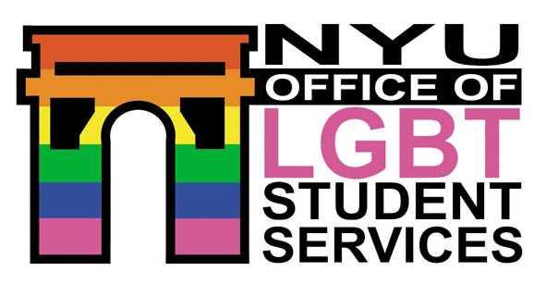 | Office of LGBT Student Services  New York University  60 Washington Square South, suite 602  New york, New York 10012 | Web: nyu.edu/lgbt  Phone: 212.998.4424  Fax: 212.995.4728

OFFICE ASSISTANT EMPLOYMENT APPLICATION
GRAPHIC DESIGN
All Applications & Resumes due no later than Friday, April 13, 2007!

PERSONAL INFORMATION
LAST NAME |  |  | FIRST NAME |  |  |  |  |  | M.I. |  |  | PREFERRED NAME
MAJOR(S) & SCHOOL |  |  | STUDENT STATUS: |  |  |  | FRESHMAN |  |  | SOPHOMORE |  |  |  | JUNIOR
 |  |  |  |  |  |  | SENIOR |  |  | GRADUATE
 |  |  | EXPECTED GRADUATION DATE
Please choose one:
December May Year:
HOME ADDRESS
STREET
CITY |  |  |  | STATE |  |  |  |  |  |  |  |  | ZIP
PHONE |  |  |  |  |  | EMAIL ADDRESS (INCLUDING NYU NET ID)
( ) -
EMPLOYMENT INFORMATION
WILL YOU BE IN THE NEW YORK CITY AREA THE ENTIRE UPCOMING ACADEMIC YEAR? YES NO
IF ANSWERED NO, PLEASE EXPLAIN:
HOW MANY HOURS PER WEEK ARE YOU AVAILABLE TO WORK?

PLEASE INDICATE THE HOURS YOU ARE AVAILABLE TO WORK EACH DAY

Please note that the LGBT Office is open Monday-Thursday 9am-8pm and Friday 9am-5pm during the academic year.
MONDAY | TUESDAY | WEDNESDAY |  |  | THURSDAY |  |  | FRIDAY |  |  | SATURDAY |  |  | SUNDAY
 |  |  |  |  |  |  |  |  |  |  | OFFICE  CLOSED |  |  | OFFICE  CLOSED

PLEASE ALSO COMPLETE SECOND PAGE

SPECIAL JOB SKILLS
SKILL | PLEASE DESCRIBE
GENERAL COMPUTER SKILLS
(Typing, Microsoft Office Products), Email, Web Browsing, etc.)
GRAPHIC DESIGN PROGRAMS
(Photoshop, Quark, In Design, Illustrator, etc.)
OTHER

PAST EMPLOYMENT/VOLUNTEER HISTORY
EMPLOYER NAME AND ADDRESS | JOB TITLE AND RESPONSIBILITIES | DATES EMPLOYED
 |  | FROM:
 |  | TO:
EMPLOYER NAME AND ADDRESS | JOB TITLE AND RESPONSIBILITIES | DATES EMPLOYED
 |  | FROM:
 |  | TO:
EMPLOYER NAME AND ADDRESS | JOB TITLE AND RESPONSIBILITIES | DATES EMPLOYED
 |  | FROM:
 |  | TO:

REFERENCES
NAME | PHONE | RELATIONSHIP
NAME | PHONE | RELATIONSHIP

PLEASE SIGN BELOW
I certify that all the information entered is true and complete to the best of my knowledge, and I understand that any false or missing job-related information may disqualify me from this position.
SIGNATURE | DATE

RETURN COMPLETED APPLICATIONS AND RESUMES TO:

OFFICE OF LGBT STUDENT SERVICES
60 WASHINGTON SQUARE SOUTH, SUITE 602
NEW YORK, NY 10012

For questions, please contact Name at e-mail.

