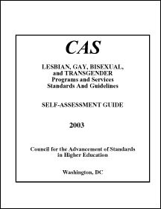
Lesbian, Gay, Bisexual, and Transgender Programs (Downloadable RTF)
This Self-Assessment Guide (SAG) translates the CAS Lesbian, Gay, Bisexual, and Transgender (referred to herein as LGBT) Program Standards into a format designed to facilitate self-assessment. Program administrators can use this Guide to gain informed perspectives on the strengths and deficiencies of their services and programs and to plan for improvements. Grounded in the self-regulation approach to quality assurance in higher education endorsed by CAS, this SAG provides institutions with a tool to assess their programs and services using international standards of practice.
The Introduction outlines the self-assessment process, describes how to put it into operation, and is organized into six sections. These include I Purpose and Organization, II Self-Assessment Process, III Rating Examples, IV Formulating an Action Plan, V Internal Benchmarking, and VI CAS Standards Feedback. The introduction is followed by the Self-Assessment Worksheet, which presents the CAS LGBT Standards in 13 components and incorporates a series of criterion measures for rating purposes.

This PDF can be purchased from the Council for the Advancement of Standards in Higher Education at www.cas.edu/

