Queer Resource Center Permanent Space Proposal

914 Monroe

Project Overview July 2002

The Queer Resource Center staff, student constituents, and advisory board members have identified a promising site to serve as the permanent location for the center.

A small house located on the northeast section of campus at 914 Monroe has been occupied by a community organization called The Sunflower House. It will soon become available when The Sunflower House vacates the facility.

914 Monroe is one of the few stand-alone buildings of its size remaining on campus as a possible site for the Queer Resource Center. It is absolutely necessary to the existence and for the success of the QRC that this space is secured as its permanent location. This space needs to be set aside for the QRC before it is reallocated to another department, or demolished.

In order to fund the renovation process of the 914 Monroe site, the Queer Resource Center Advisory Board, volunteers, and interns are committed to the pursuit of grants, donors, and fundraising.

Additionally, the Queer Resource Center and Student Involvement are eligible for a contingency request from the Student/Incidental Fees Committee in order to fund some portions of the renovation process.

More extensive details regarding this project are contained in this document. If you have any questions, or require additional information, please contact the Diversity Development Office at Number, or the Queer Resource Center at Number.

Name
Diversity Development Coordinator

Name
Queer Resource Center External Coordinator

Name
Queer Resource Center Advisory Board Member

The Queer Resource Center July 2002

Mission Statement:
“The OSU Queer Resource Center provides programs and support services for lesbian, gay, bisexual, transgender, queer, questioning and intersexed members of the OSU community and their allies. The QRC affirms the identities and empowers the lives of LGBTQQI people by providing education, outreach, program support, consultation, community development, visibility and advocacy. The QRC is a safe space for all members of our community to explore aspects of sexual orientation and gender identity in an open and non-judgmental atmosphere.”

Established in March of 2001, commissioned in October 2001, and operational as of January 2002 the Queer Resource Center has been profoundly successful as an institutionalized resource for lesbian, gay, bisexual, transgender, queer, questioning, intersex students and allies at Oregon State University and in the Corvallis community. The QRC has extended itself to the community at Oregon State University as a positive and energetic means of providing both a safe space for the LGBTQQI community, and educational opportunities for the OSU community as a whole.

During Winter and Spring terms of 2002, the Queer Resource Center was staffed minimally with two coordinators. Each coordinator was paid to work only 10-12 hours per week, despite the demand on the center for additional personnel. During this initial stage the QRC was placed in a converted storage space generously on loan from the Women’s Center. It was funded at only $7000.00, which included payroll, for the 2001-2002 academic year. Through a troubled but successful budgeting cycle, the QRC has been funded at $22,440.00 for the 2002-2003 academic year. This will provide funding for two student coordinators at 18-20 hours per week, and one student Public Relations Coordinator at 10-12 hours per week. The 2002-2003 annual programming budget (from within the $22,440.00) will rest at a low $5,950.00

The goals set for future budget projections for QRC are as follows:
2003-2004 $28,000.00
2004-2005 $34,000.00
2005-2006 $44,000.00
2006-2007 $64,000.00

Based on the above budgeting goals, the future staffing goals for the QRC are as follows:
2003-2004 ($28,000.00)
2 Co-Coordinators
1 Public Relations Coordinator
2 Office Assistants

2004-2005 ($34,000.00)
2 Co-Coordinators
1 Public Relations Coordinator
1 Community Outreach Coordinator
1 Activities Coordinator
2 Office Assistants

2005-2006 ($44,000.00)
1 Graduate Teaching Assistant/Coordinator
1 Public Relations Coordinator
1 Activities Coordinator
1 Community Outreach Coordinator
4 Office Assistants

2006-2007 ($64,000.00)
1 Graduate Teaching Assistant/Coordinator
1 Public Relations Coordinator
1 Activities Coordinator
1 Community Outreach Coordinator
4 Office Assistants

The Queer Resource Center is committed to providing the Oregon State University community with opportunities for growth and development around issues of heterosexism and homophobia. This stigmatized topic has virtually been omitted from contemporary education. Recent social movements made progress in understanding the oppression that people in the LGBTQQI community face, and affirming those who are members of a relational and affectional minority group.

Needs Assessment July 2002

As the Queer Resource Center enters its next full year in operation, it is clear that the current location of the QRC cannot support its growth any longer. Currently, the QRC is located in a converted storage room in the Women’s Center with one desk, one bookshelf, and two pieces of lounge furniture. This space is below the minimum needs of an organization with the mission of the QRC.

Using the four existing Cultural Centers at Oregon State University as a model, the Queer Resource Center was conceived and is designed to provide a physical environment including the following:
- Conference meeting space
- Private consulting and counseling space
- Kitchen facilities
- Computer laboratory facilities
- Lounge space
- Library resource space
- Program planning space
- Storage space
- Restroom Facilities
- External event/program space (deck, lawn, etc.)

At this time, the QRC has none of the above listed resources. It is absolutely necessary to the success of the QRC that a facility be obtained, or potentially be altered to meet these needs.

Project Objectives and Timeline July 2002

The primary objective of relocating to the 914 Monroe location includes establishing the physical environment as outlined in the Needs Assessment section of this proposal.

Location:
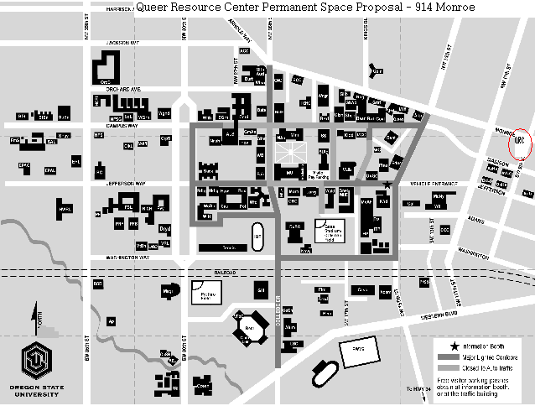

The following timeline projects a general concept of the renovation and relocation project.

July 02
→Submit proposal for the 914 Monroe site to be the permanent location of the Queer Resource Center

August 02
→Conduct a facility inspection in order to identify renovation and/or remodeling needs
→ Identify funding needs for renovation and/or remodeling
→Begin grant-writing, donor identification, fundraising, and contingency allocation requests

September 02
→ Begin grass-roots cleanup project involving community members and donated resources (cleaning, painting, minor repairs)

December 02
→ With potentially approved contingency reallocation, implement Winter 03 through Summer 03 remodeling schedule in cooperation with Memorial Union Maintenance personnel and Facilities Services

Winter 03
→ Add telecom and networking lines
→ Official relocation of QRC to 914 Monroe, facility permitting

Spring 03
→ Continued renovation/remodeling

Summer 03
→ Long-term renovation assessment and planning for 2003-2004, and 2004-2005, etc.

Project evaluation:

The Queer Resource Center receives administrative support from the Diversity Development Office and the Office of Student Involvement, and is funded through the Student/Incidental Fees Process. Because of this support structure, the QRC is evaluated at many different levels.

As the primary administrative unit attached to the QRC, the Diversity Development Office provides constant evaluation and support to the Queer Resource Center, particularly around QRC staff, facility operations, budget expenditures, center development, and programming.

The Office of Student Involvement provides additional budgetary and administrative support for budget expenditures as well as leadership development and departmental evaluation.

The student advisory board for the Office of Student Involvement that becomes active beginning Fall 2002 will provide student advising and guidance to Student Involvement functional areas, including the QRC. As with other student advisory boards (Memorial Union Board, Student Health Advisory Committee, RecSports Board, etc.) the Student Involvement advisory board will also provide a level of evaluation.

The Queer Resource Center also receives support through the yearly budgeting process. The Student/Incidental Fees Committee and the ASOSU Senates provide budgeting guidance to all Student/Incidental Fee funded areas. Throughout the budgeting process, these student committees provide evaluation and assessment, particularly around resource and funding needs, program development, and project design.

The Queer Resource Center also has its own stand-alone advisor board dedicated to the success of the center. This board consists of community members from OSU, OSU alumni, Corvallis, Eugene, Portland, etc. Each member is active on subcommittees that work on projects for center development. As an advisory board, this body is responsible for providing direct evaluation from community members and guidance throughout each year.

Open Minds. Open Doors

The Queer Resource Center must have the support to assist Oregon State University with its mission of fulfilling a commitment to Diversity. By allocating the 914 Monroe site to the Queer Resource Center, OSU can further that commitment. The student staff and constituents need to be empowered to seek success, and this site will provide an ideal platform for empowerment.

We urge you to provide institutional support to the LGBTQQI community by allocating the 914 Monroe site as the permanent home for the Queer Resource Center.

Queer Resource Center Permanent Space Proposal

914 Monroe

Drafted July 2002

