GET ON THE BUS!

Friday, January 4, 2008

Lot 24, on Canyon Crest Drive
[across from Getaway Café/Bannockburn]

BUS LEAVES at 3:00pm

Arrive at 2:45pm to load luggage

Nancy’s cell phone: 951.334.6740

Bus will return to same location by 5:00pm Sunday.

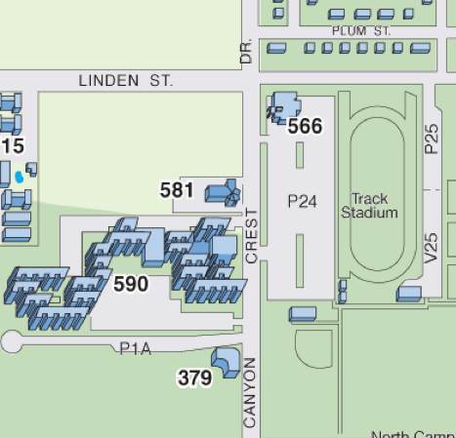

Snow Camp Supplies

What To Bring:
- Sleeping bag
- Blanket
- Warm pajamas
- Pillow
- Towels
- Toiletries
- Earplugs, if you need quiet to sleep
- Snacks to share – none will be brought from the LGBTRC. S’mores, anyone?
- Pens, pencils, notebook
- Board games or other pleasant things to share around the fireside
- Warm, layered, comfortable clothes (it may be COLD up there in the snow!!!)
- Mittens, woolly hats, earmuffs, thermal underwear, whatever it takes
- Comfortable, sensible shoes, including a spare pair for when one pair gets wet
- Hiking shoes or boots if you think you might want to join a hike
- Flashlight
- Sense of humor
- Any pharmaceuticals or over-the-counter medication you might need
- FOR THE TALENT SHOW: any props, readings, costumes, etc.
- FOR THE DANCE: any music on CD.
What NOT to bring:
- Pets
- Parents
- Alcohol
- Drugs (the illegal variety)
- Attitude
- Bicycles
- Your entire wardrobe - casual is fine!
What will be provided:
- Marshmallows (from Nancy, because she’s addicted.)
- A calendar (January through June, 2008) for planning
- Craft supplies (markers, paper, scissors, glue)
- A few games – playing cards, backgammon
- All meals from Friday dinner to Sunday lunch
- Transportation on a bus to and from the camp and UCR campus

Winter Student Retreat Agenda
January 4-6, 2008 @ Camp de Benneville Pines

Friday
3:00 Get on the bus, ya’ll
5:00 Arrive at Camp
5:30 Opening Ceremonies @ Lodge
6:30 Dinner
7:30 Energizer/Icebreaker
7:45 Our Stories
8:30 Trust Exercise
8:45 Home Groups
9:00 Bowl of Questions
Night Games, music, gossip, bedtime

Saturday
8:00 Breakfast w/Home Groups
8:45 Energizer/Icebreaker
9:00 Bowl of Questions
9:30 Group Activity
11:15 Break
11:30 Building Common Ground
12:30 Lunch
1:30 Group Activity
2:30 Free time & Discussion circles & Snowpeeps – 2 1/2 hours
5:00 Bowl of Questions
5:30 Home Groups
6:00 Dinner
7:00 Group Activity
9:00 Prepare for Talent Show or Screening @ Coffeehouse
9:30 Social – Talent Show & Dance

Sunday
8:30 Breakfast
9:00 Energizer/Icebreaker
9:30 Group Activity
11:00 Bowl of Questions
11:30 Group Sharing
12:30 Lunch
1:15 Home Groups
1:30 Written Evaluations and Group Photo
2:00 Break, pack, clean up after ourselves
3:00pm Back on the bus, ya’ll!
4:30pm Arrive at UCR campus

