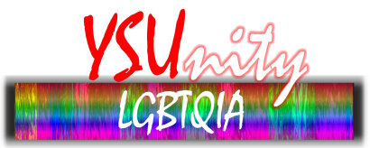
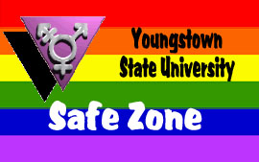

Safe Zone Advocate Pledge

As a Safe Zone Advocate at Youngstown State University I make the following pledge:

- to continue my duties as a Safe Zone Ally

- to provide support, mentorship, and empowerment to new Safe Zone Allies

- to guide individuals in need to appropriate resources on and off campus to ensure they have a safe and comfortable learning and home environment

- to understand my limitations and refer to other advocates and resources when necessary

- to speak up and take necessary action when I witness injustice on campus

- to be aware of issues which face the LGBTQIA community by continuing to educate myself and those around me

- to incorporate LGBTQIA knowledge into my professional activities

Signature___________________________________________Date:_________________

Printed Name _______________________________________Dept.: _______________

By signing this contract, I give permission to publish my name
and department location as a Safe Zone on campus.

When this pledge is signed and returned to Brian Wells in the Bitonte College of Health and Human Services, a Safe Zone Advocate sign will be sent to you so that you may be identified as a Safe Zone Ally and Advocate.

