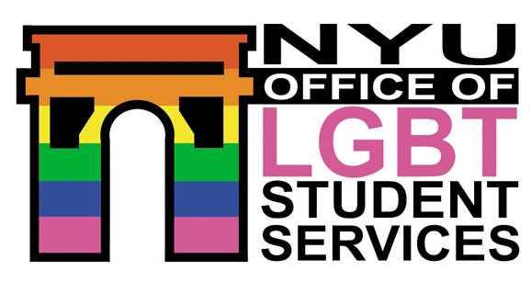 | Office of LGBT Student Services  New York University  60 Washington Square South, suite 602  New york, New York 10012 | Web: nyu.edu/lgbt  Phone: 212.998.4424  Fax: 212.995.4728

OFFICE ASSISTANT EMPLOYMENT APPLICATION
Outspoken Program assistant
All applications are due no later than Friday, April 13, 2007 at 5pm!

PERSONAL INFORMATION
LAST NAME |  |  | FIRST NAME |  |  |  |  |  | M.I. |  |  | PREFERRED NAME
MAJOR(S) & SCHOOL |  |  | STUDENT STATUS: |  |  |  | FRESHMAN |  |  | SOPHOMORE |  |  |  | JUNIOR
 |  |  |  |  |  |  | SENIOR |  |  | GRADUATE
 |  |  | EXPECTED GRADUATION DATE
Please choose one:
December May Year:
HOME ADDRESS
STREET
CITY |  |  |  | STATE |  |  |  |  |  |  |  |  | ZIP
PHONE |  |  |  |  |  | EMAIL ADDRESS (INCLUDING NYU NET ID)
( ) -
EMPLOYMENT INFORMATION
WILL YOU BE IN THE NEW YORK CITY AREA THE ENTIRE UPCOMING ACADEMIC YEAR? YES NO
IF ANSWERED NO, PLEASE EXPLAIN:
HOW MANY HOURS PER WEEK ARE YOU AVAILABLE TO WORK?

PLEASE INDICATE THE HOURS YOU ARE AVAILABLE TO WORK EACH DAY

Please note that the LGBT Office is open Monday-Thursday 9am-8pm and Friday 9am-5pm during the academic year.
MONDAY | TUESDAY | WEDNESDAY |  |  | THURSDAY |  |  | FRIDAY |  |  | SATURDAY |  |  | SUNDAY
 |  |  |  |  |  |  |  |  |  |  | OFFICE  CLOSED |  |  | OFFICE  CLOSED

PLEASE ALSO COMPLETE SECOND PAGE

Why are you interested in being the Outspoken Program Assistant?
What specific skills and/or strengths would you bring to this position?

PLEASE RETURN COMPLETED APPLICATIONS AND RESUMES VIA EMAIL TO:

NAME
ADDRESS
EMAIIL

